README – Grazioso Salvare Dashboard_Andre Miranda_

Overview
The Grazioso Salvare dashboard is the front-end component of the project. It provides an interactive, data driven interface for exploring the Austin Animal Center (AAC) dataset using the CRUD module developed. The dashboard is built using Plotly Dash, Dash Leaflet, and Pandas, and integrates directly with the MongoDB AnimalShelter class.
The purpose of the dashboard is to allow users at Grazioso Salvare to quickly identify animals suitable for specialized rescue training programs. The interface includes:
- A dynamic data table
- Three rescue specific filters
- A reset view
- A breed distribution pie chart
- An interactive map with a floating info card
- Organization branding and a clean, modern UI
This dashboard demonstrates how the CRUD module can be integrated into a real application and used to support decision making.

How to Run the Dashboard
- Ensure MongoDB is running in the Codio environment.
- Ensure the CRUD module (CRUD_Python_Module.py) is in the same directory as the dashboard notebook.
- Open ProjectTwoDashboard.ipynb in Jupyter.
- Run all cells.
- The dashboard link will be created:
Code
app.run_server(mode="external", port=8051)
- Click the external link that appears in the notebook output to open the dashboard in a browser tab.
Dashboard Layout and Features
1. Branding Header
The top of the dashboard includes:
- The Grazioso Salvare logo
- The dashboard title
- A unique identifier (“Created by Andre Miranda”)

2. Rescue Filter Controls
The dashboard includes four radio-button filters:
- Water Rescue
- Mountain/Wilderness Rescue
- Disaster/Tracking Rescue
- Reset
Each filter triggers a callback that queries MongoDB using the corresponding method in the CRUD module:
- filter_water_rescue()
- filter_mountain_rescue()
- filter_disaster_rescue()
- read_all()
These filters apply breed, age, and sex criteria defined by Grazioso Salvare.
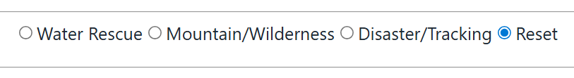

3. Data Table
The table displays all fields returned from MongoDB, including:
- Animal ID
- Name
- Type
- Breed
- Sex
- Outcome
- Age in weeks
- Latitude/Longitude
Features include:
- Sorting
- Filtering
- Pagination
- Single-row selection
The selected row drives the map and info card.
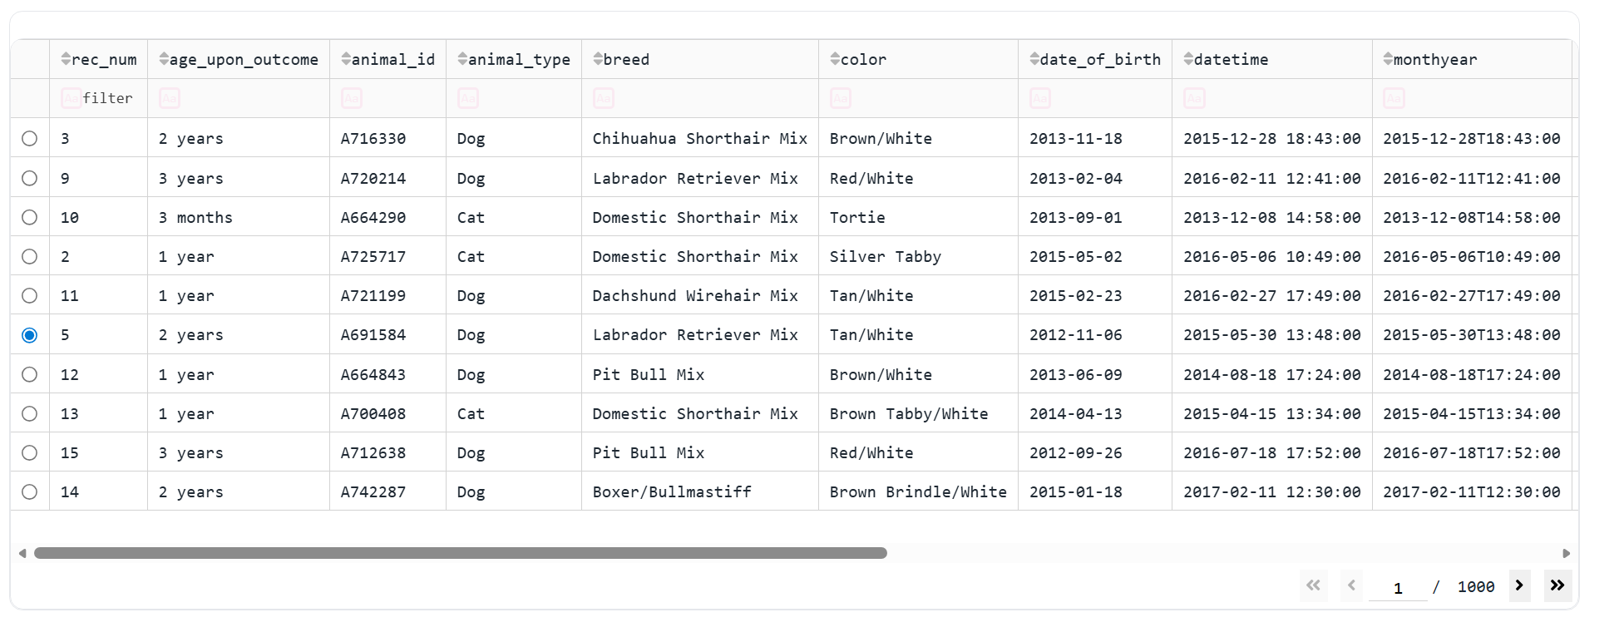

4. Breed Distribution Pie Chart
The pie chart updates dynamically based on the filtered dataset. Mixed-breed strings are normalized and split into individual breeds before counting, ensuring accurate distribution.
To avoid unreadable charts when many breeds are present (especially in Reset mode), the dashboard groups all but the top 8 breeds into a single category:
“Other Breeds”
This produces a clean, readable visualization that still reflects the distribution of the data.
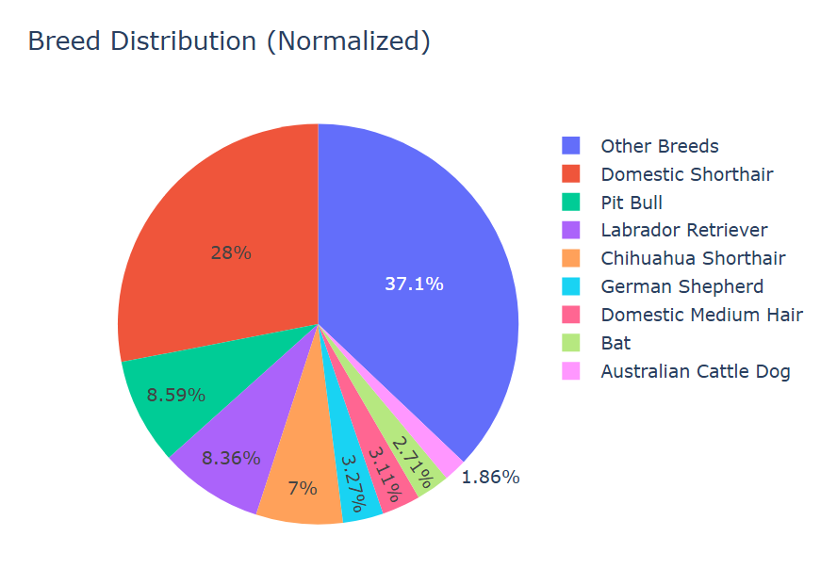
5. Interactive Map and Info Card
When a row is selected in the table:
- The map centers on the animal’s latitude/longitude
- A marker is placed at the location
- A tooltip shows the breed
- A popup displays the animal’s name
- A floating info card shows key details:
  - ID
  - Name
  - Type
  - Breed
  - Sex
  - Outcome
  - Age in weeks
This provides a clear, intuitive way to explore the geographic distribution of animals.
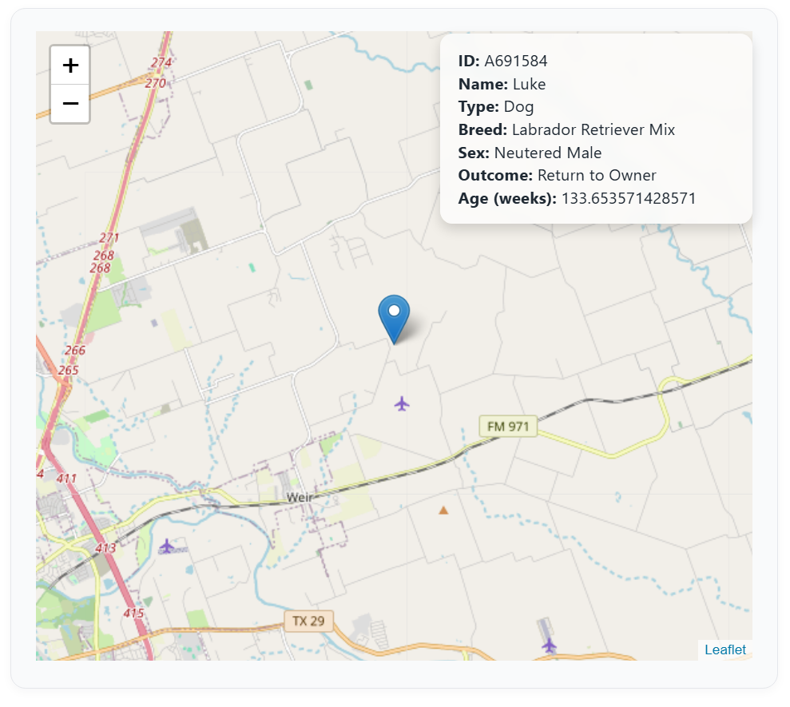

Callback Architecture
The dashboard uses three main callbacks:
1. update_table()
Triggered by the rescue filter. Returns filtered MongoDB records to the DataTable.

2. update_graph()
Triggered by changes to the DataTable’s virtual data. Builds the pie chart with top-N grouping.

3. update_map()
Triggered by:
- Table data
- Selected row
Updates both the map and the info card.
This architecture keeps the dashboard responsive and ensures all components stay synchronized.

Integration with the CRUD Module
The dashboard relies entirely on the AnimalShelter class for data access. All filtering logic is performed server-side in MongoDB, not in Python. Each rescue filter uses server-side regex breed matching, age constraints, and sex requirements defined in the CRUD module.
This demonstrates:
- Proper separation of concerns
- Clean integration between backend and frontend
- Reusability of the CRUD module in real applications

